**Multimedia Processing and Application Project - Image Mosaicing**

**Submitted by:**

Jatin Keswani (16ucs081)

Preksha Pandey (16ucs139)

**Objective:**

Creating a new image by stitching 6 separate images of the same blackboard to get the complete blackboard image.

**Introduction:**

Mosaicing is a technique to stitch images from the assembling of small pieces of separated images to get the whole image. In mosaicing, we take minimum 4 points from each image to blend them to get a combined Image.

**Procedure:**

1. In the beginning, we load all 6 images in MATLAB and store them in variables from I1 to I6.
2. Then we either take input from the user by mouse click on the image to get there coordinate values or we hard-code the coordinate values.
3. Then for every coordinate values ‘main’ function is called from which all other functions are called for mosaicing.
4. We send the coordinates value (x1,y1,x2,y2) to Homography function.
5. In Homography function, there is a A matrix whose output is used as an input in SVD function.

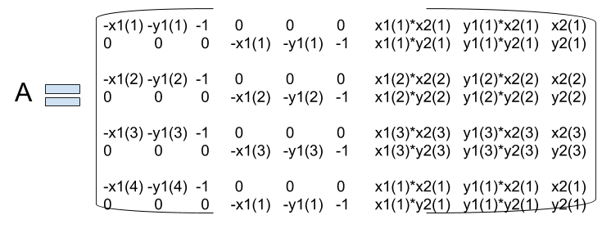

1. SVD returns 3 matrix from which we need only last matrix V. V is a 9X9 matrix and we need only last column which we convert into 3X3 HOMOGRAPHY matrix and we then return HOMOGRAPHY and INVERSE HOMOGRAPHY MATRIX.
2. Then we multiply boundary point of the perspective image with inverse homography matrix to get new boundary points.
3. Then we take MINX MINY MAXX MAXY from boundary points of world image and the coordinates we calculated in the last step.
4. Then we create an array of size of [(absolute)minx+maxx,(absolute)miny+maxy), then we create copy previous world image at increased offset.
5. Then we traverse whole world map matrix to find the corresponding point by inverse mapping of homography matrix in perspective image and if there is a color value then we paste it to world image.
6. Then we repeat all the steps from 4 to 10 till we get the resultant image.

**Design Decision:**

Mosaicing is a technique which we have used to stitch images to get a complete image. In this, we give world image, perspective image and all the coordinates as an input parameter, which undergoes the process of inverse homography to get the final image.

**Observations:**

1. After stitching there is some data loss as some data is overlapped or not stitched in its perfect position. We can extract most of the data but there will always be some data loss.
2. As we stitch any two images there are some black spots (offset area which is not used) area which is created due to misalignment of another image at some angle. This increases the image size which has no useful data in black spots.
3. While doing forward mapping we notice some small holes because we get some floating point values that are not present in the world image array. That’s why we have done the inverse mapping.

**Result:**

1. The result after stitching image 1 and image 2 we get resulting image12

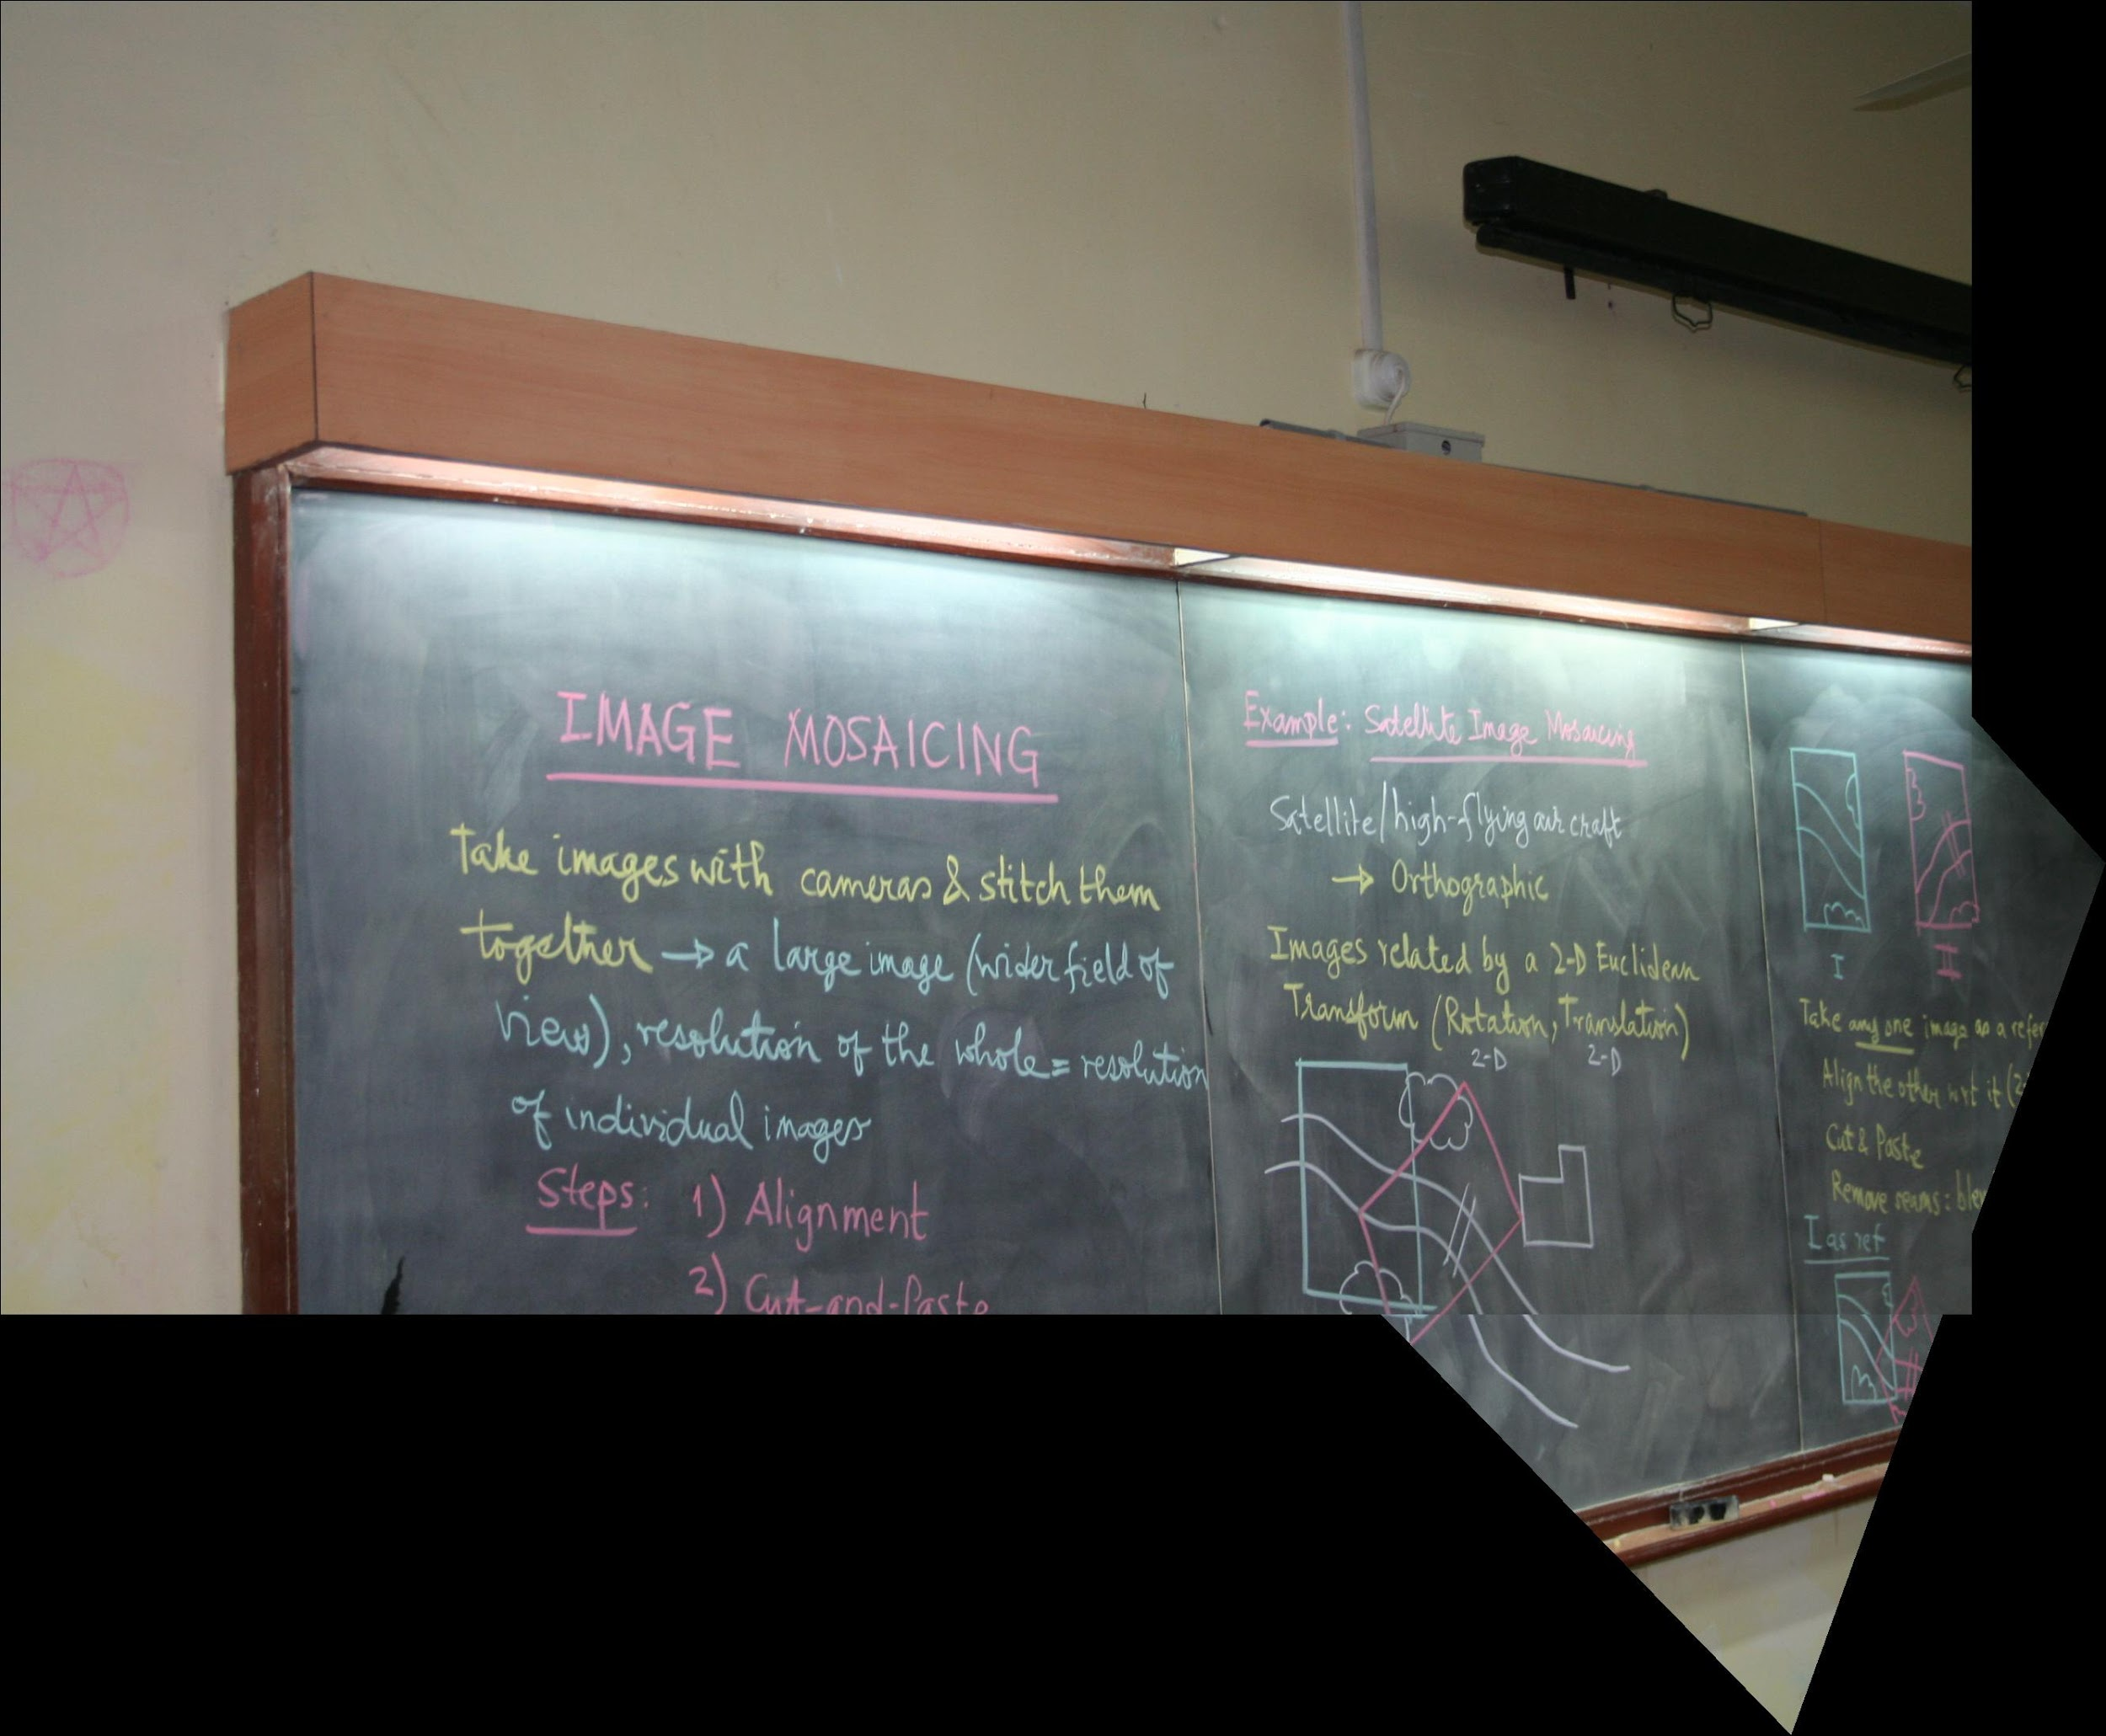

2. The result after stitching image 12 and image 3 we get resulting image123

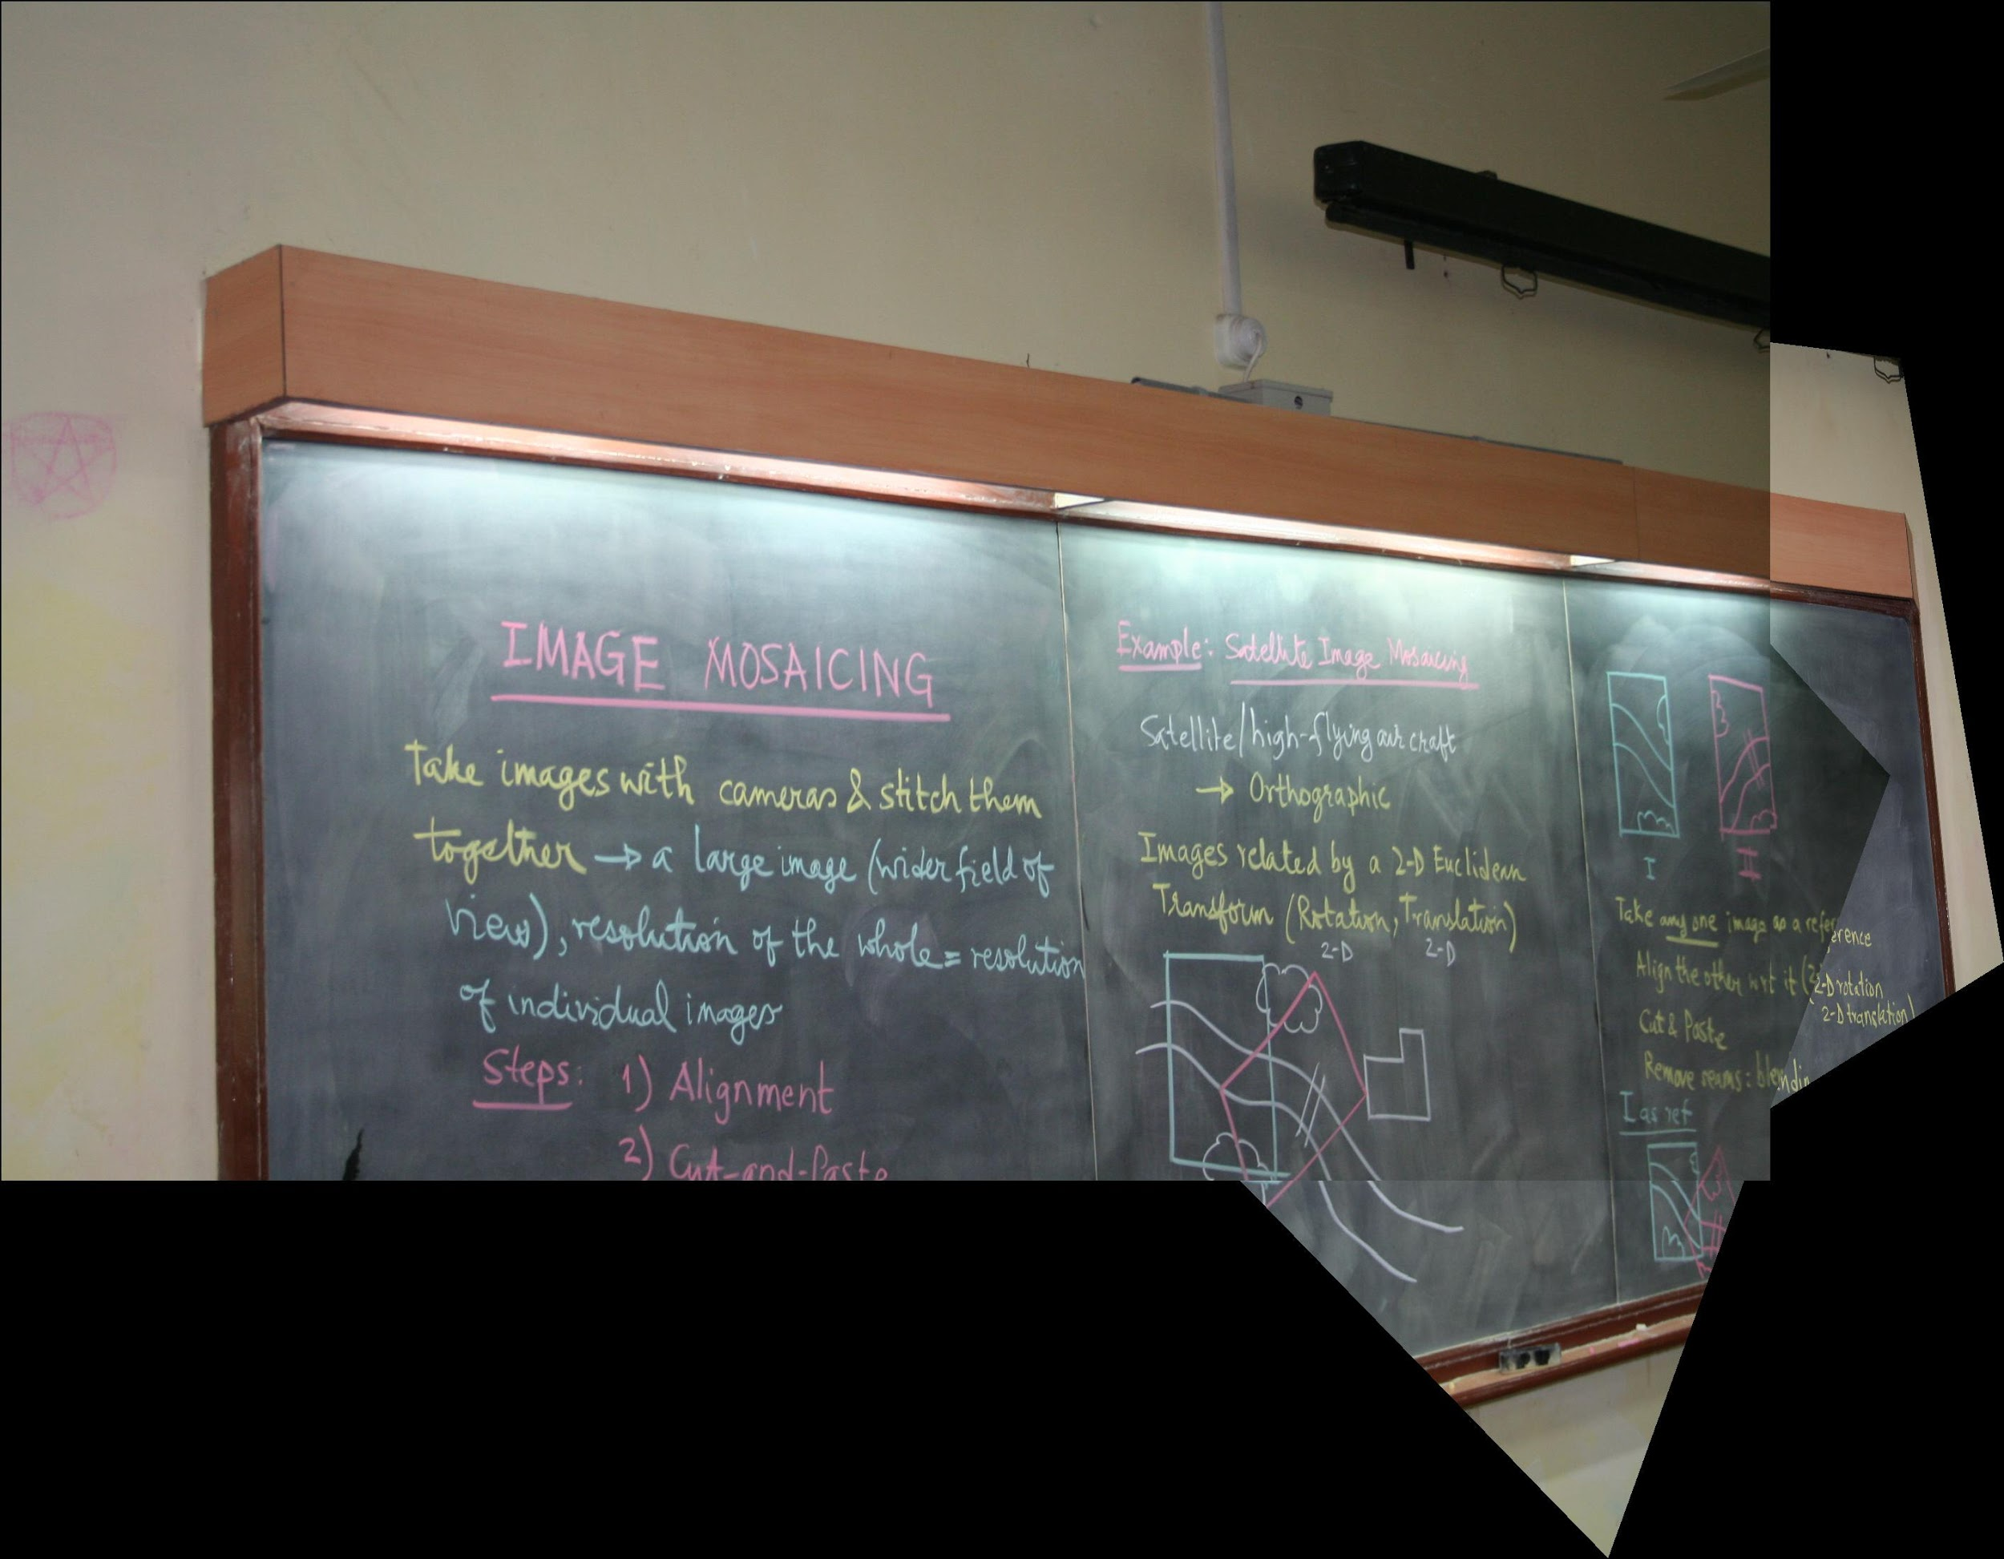

3. The result after stitching image 123 and image 4 we get resulting image1234

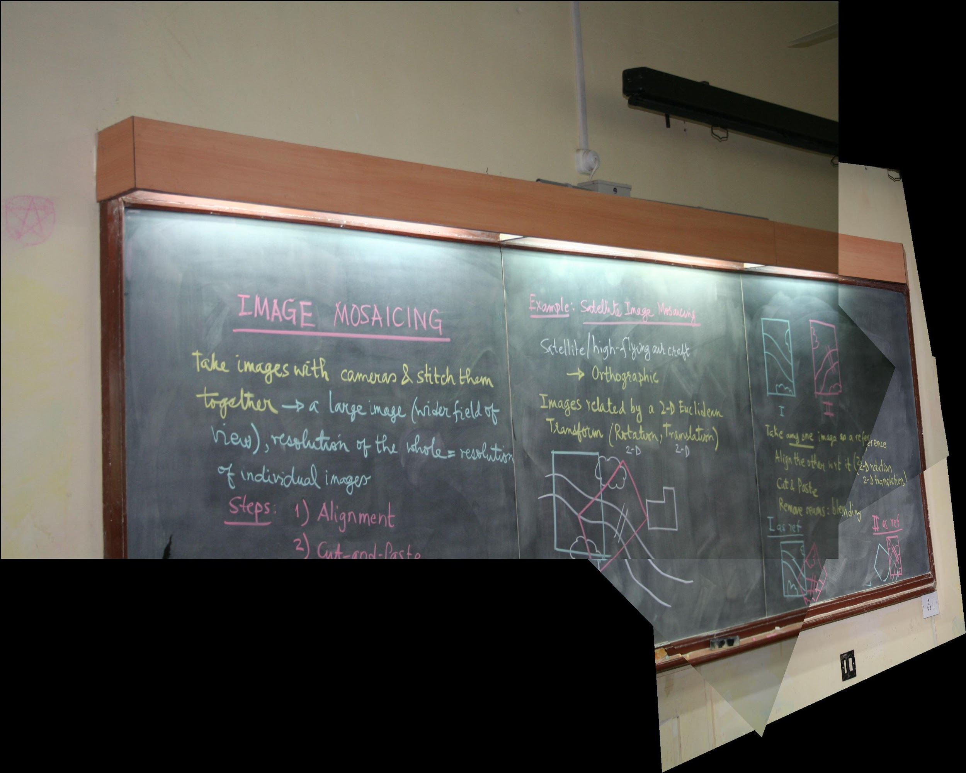

4. The result after stitching image 1234 and image 5 we get resulting image12345

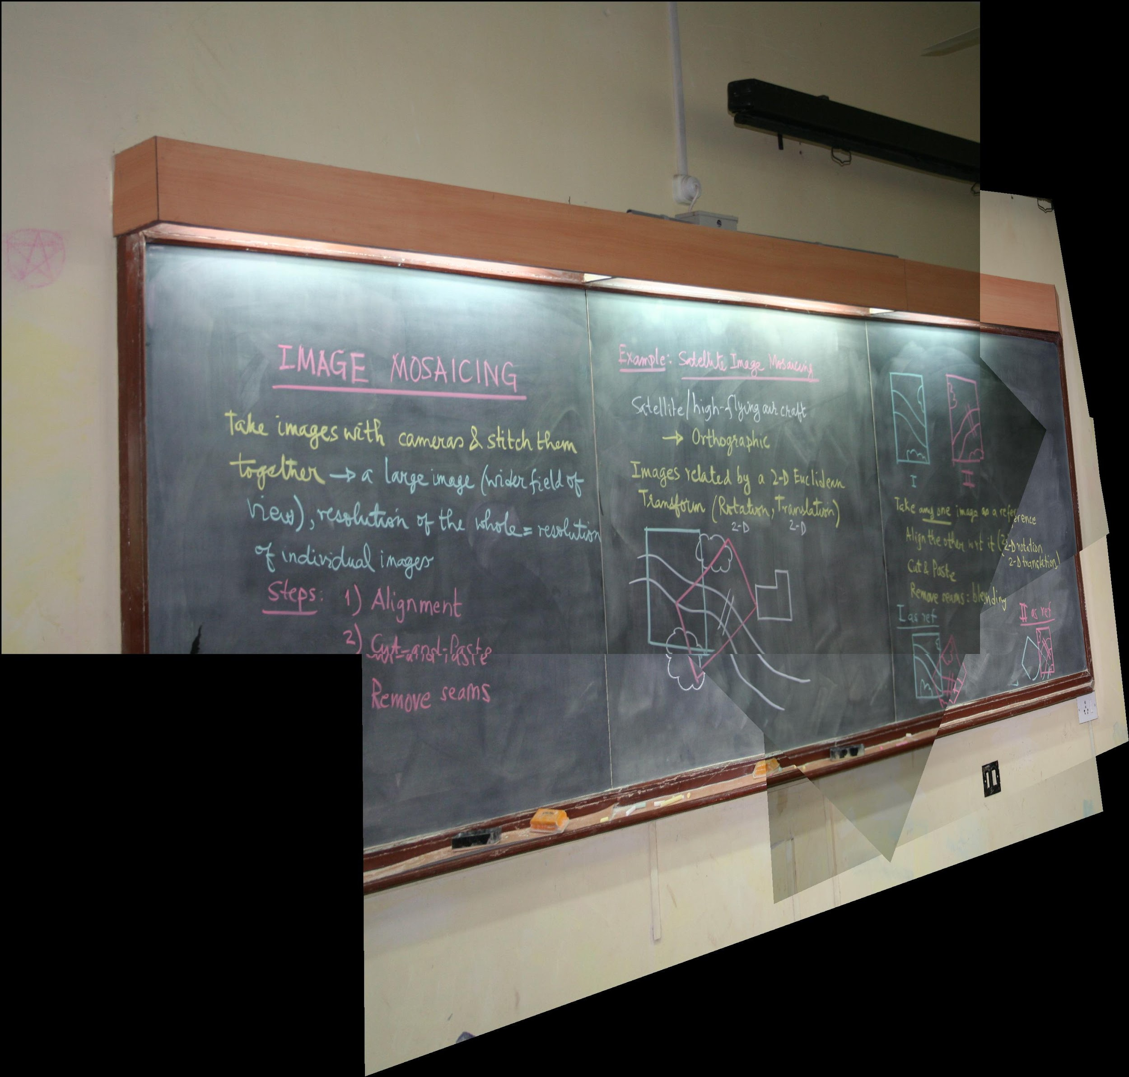

5. The result after stitching image 12345 and image 6 we get resulting image123456

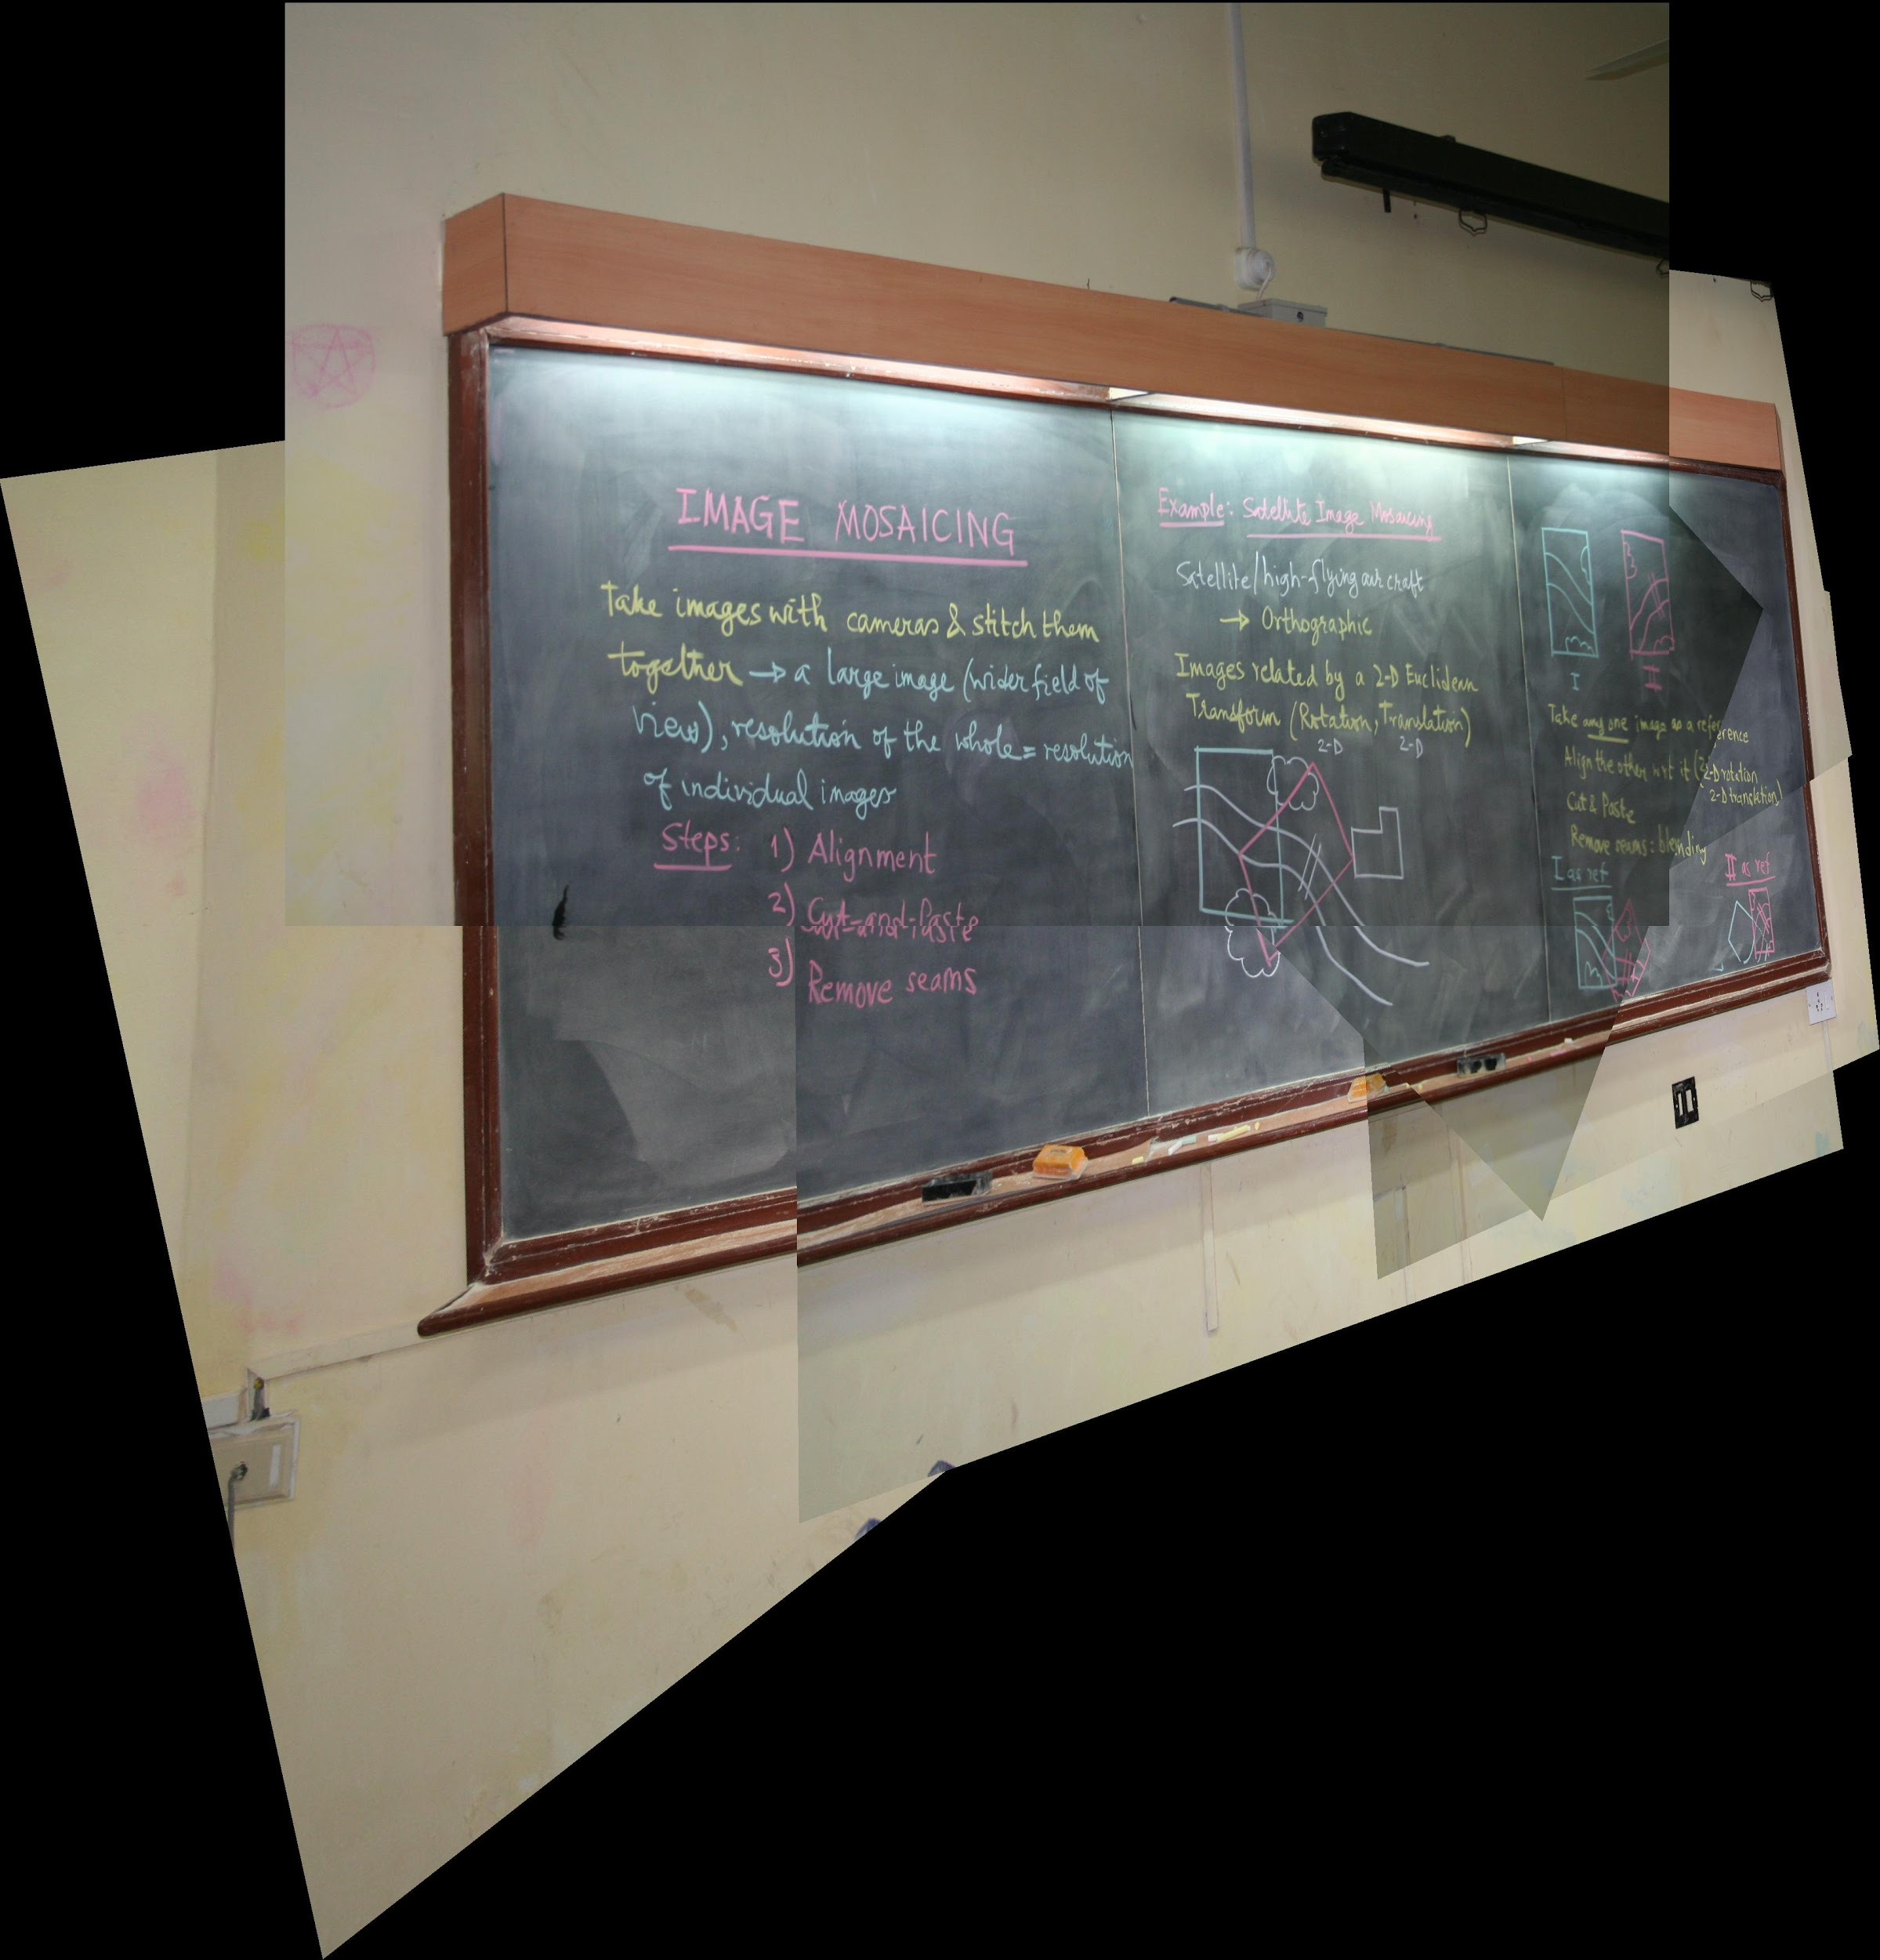

Hence, we get the resultant image of the complete blackboard as a result of mosaicing of the 6 separate images of the blackboard.